**Assignment No. 9**

**Name:- Aditya Zade**

**PRN:- 2018BTECS00111**

**Problem 1:-**

**Code:-**

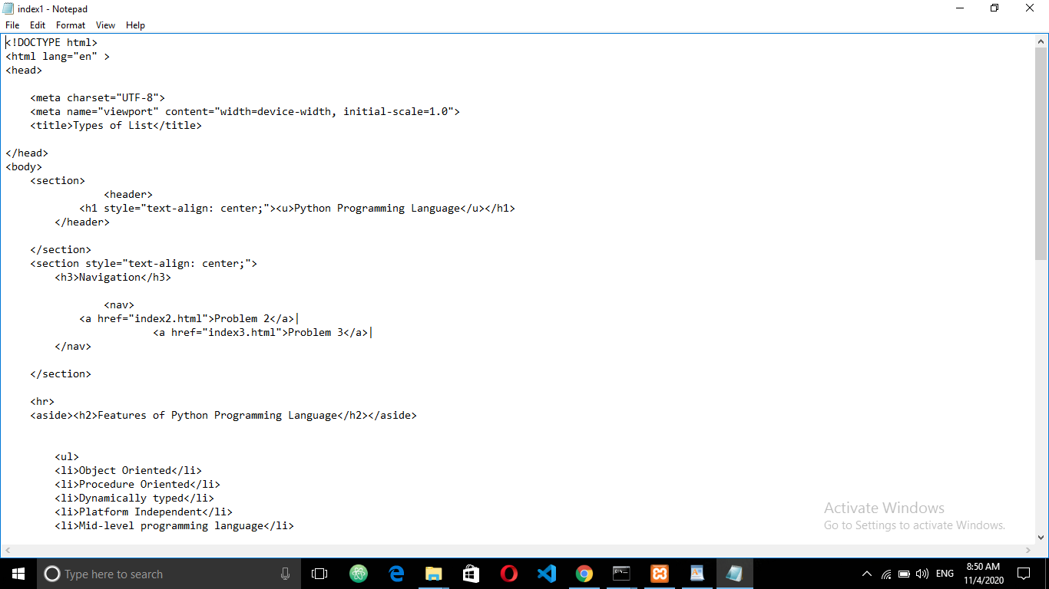

**Webpage:-**

